
COURSE TITLE: INTERNET AND MOBILE PROGRAMMING

UNIVERSITY OF
BUEA

FACULTY OF
ENGINEERING AND
TECHNOLOGY
(FET)

TASK 4:
System Modelling and Design

Name | Matricule
Akoh Mcpeace Njoh | FE23A009
Mugha Brayan aya-ah Ndefru | FE23A097
Eyong Akago Anelka Nelvine | FE23A056
Ngolien Lucy Ethel Libog | FE22A261

1 Introduction

This section presents the complete system modelling and design artefacts for the proposed mobile application tasked with collecting Quality of Experience (QoE) data from mobile network subscribers. System modelling translates requirements and business logic into structured visual representations that guide the development process, facilitate communication among stakeholders, and serve as a blueprint for implementation.
The diagrams contained in this report cover six complementary perspectives of the system: the context diagram establishes the system boundary and its interactions with external actors; the dataflow diagram illustrates how data moves through the system; the use case diagram captures functional requirements from the user perspective; the sequence diagram details the temporal order of interactions; the class diagram defines the object-oriented structure of the application; and the deployment diagram specifies the physical and logical infrastructure required to run the system.
Together, these six models provide a holistic view of the system, enabling developers, network engineers, and project stakeholders to align on the architecture and behaviour of the application before and during implementation.
2. Context Diagram

2.1 Overview

The context diagram, also referred to as a Level 0 Data Flow Diagram, defines the system as a single process and situates it within its operational environment. It identifies all external entities that interact with the system and shows the high-level data flows entering and leaving the system boundary, without describing any internal processing logic.

2.2 External Entities
The following external entities interact with the QoE Data Collection System:
- Mobile Subscriber: The primary user of the application. The subscriber interacts with the system by responding to dynamic notification prompts delivered to their device and submitting active survey ratings and interactions. In return, the system issues dynamic notification prompts to engage the subscriber at appropriate moments during their network usage experience.
- MNO Admin / Engineer: The principal stakeholder and consumer of processed data. The MNO Admin or Engineer receives aggregated analytics and QoE reports generated by the system, using them to monitor network performance, identify coverage and quality issues, and support network optimisation decisions.
- Android OS / iOS APIs: An external system rather than a human actor. The device operating system exposes platform-level APIs that feed dynamic notification prompts and raw telemetry data into the QoE Data Collection System, enabling passive collection of network and device parameters without direct user intervention.

2.3 Key Data Flows
The principal data flows at the context level are as follows:
- From Mobile Subscriber to System: Active survey ratings and interactions submitted by the user in response to feedback prompts presented on their device.
- From System to Mobile Subscriber: Dynamic notification prompts that invite the subscriber to provide feedback at contextually relevant moments during their usage session.
- From Android OS / iOS APIs to System: Dynamic notification prompts and low-level telemetry signals sourced from the device operating system, supplying the system with the passive network and device data required for QoE measurement.
- From System to MNO Admin / Engineer: Aggregated analytics and QoE reports providing visibility into network performance trends, spatial coverage quality, and subscriber experience metrics.

2.4 Diagram
Figure 2.1 below presents the context diagram for the QoE Data Collection System, showing the system boundary and its three external entities — the Mobile Subscriber, the MNO Admin / Engineer, and the Android OS / iOS APIs — together with the data flows that connect them to the central system.
.
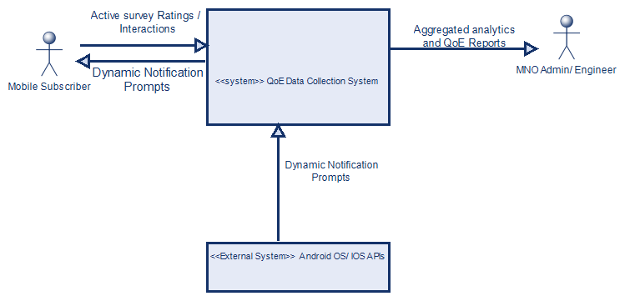3. Dataflow Diagram

3.1 Overview

The Dataflow Diagram (DFD) expands upon the context diagram by decomposing the single system process into its internal sub-processes and illustrating the data stores used by the application. The Level 1 DFD presented here identifies the major processing activities, the data flows connecting them, and the data stores that persist information between operations.
3.2 Major Processes
The system is decomposed into the following major processes:
- Process 1.1 Metrics Poller and Parser: Interfaces directly with the Android OS / iOS APIs to continuously collect raw telemetry from the device. It parses the incoming data and saves offline records as JSON logs, writing the structured output to the local data store for further processing.
- Process 2.1 Dynamic UX Form Controller: Manages the presentation of the active feedback form to the Mobile Subscriber. It receives 1–5 star ratings submitted by the user and saves the active feedback form data back to the local Room DB, linking subjective ratings to the corresponding telemetry session.
- Process 3.1 Remote Sync Engine: Monitors local storage for unsynced batches and fetches them from Room DB for transmission. It uploads the data to the Central Cloud Database via a secure HTTPS POST payload stream, ensuring reliable delivery of all pending records.
- Process 4.1 Web Dashboard Analytics Engine: Retrieves aggregated telemetry and coordinate data from the local Room DB to support spatial and statistical analysis. It generates QoE Spatial Coverage Heatmaps and Reports, which are delivered to the MNO Admin / Engineer for network monitoring and planning.

3.3 Data Stores
The application relies on the following data stores:
- Data Store 1 Room DB: An on-device local database that acts as the central buffer for all collected data. It receives parsed telemetry from the Metrics Poller, stores active feedback form submissions from the UX Form Controller, supplies unsynced batches to the Remote Sync Engine, and serves aggregated queries to the Analytics Engine.
- Data Store 2 Central Cloud Database: The remote, server-side database that receives the secure HTTPS payload streams transmitted by the Remote Sync Engine. It serves as the authoritative store for all synchronised QoE records, supporting operator-facing reporting and analytics.

3.4 Diagram
Figure 3.1 below presents the Level 1 Data Flow Diagram for the UX Data Collector Mobile Application, illustrating the four core processes, two data stores, and two external entities — the Mobile Subscriber and the MNO Admin / Engineer — along with the data flows connecting them.
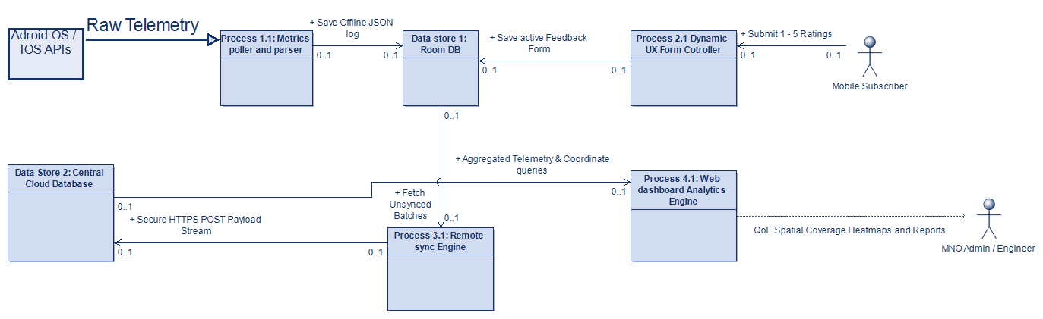

4. Use Case Diagram

4.1 Overview
The Use Case Diagram represents the functional requirements of the system from the perspective of its actors. Each use case describes a discrete goal that an actor can accomplish by interacting with the system. The diagram is drawn in accordance with the Unified Modelling Language (UML) standard.
Here is the rewritten section based on your actual use case diagram:

4.2 Actors
- Mobile User (Primary Actor): The end-user of the Mobile QoS / QoE Data App. The mobile user registers an account, grants device permissions, manages privacy controls, submits feedback, and interacts with network visualisation and reporting features.
- Network Operator (Secondary Actor): Accesses aggregated network data and reports generated by the system. The network operator uses the app to monitor QoE trends across the subscriber base and compare performance across providers.
- Android/iOS OS (Supporting Actor): An external system actor that runs background tests, logs network technology, tags signal readings with GPS coordinates, caches data offline, and sends collected data to the backend, enabling passive metric collection without direct user intervention.
- Backend Server (Supporting Actor): Receives data transmitted from the device and provides access to aggregated reports, supporting both operator-facing analytics and the app's data visualisation features.

4.3 Use Cases
Mobile User use cases:
- UC-01: Register Account
- UC-02: Log In
- UC-03: Grant GPS Permission
- UC-04: Grant Background Access
- UC-05: Manage Privacy Controls
- UC-06: Opt Out of Data Collection
- UC-07: Detect Slow Internet
- UC-08: Submit User Feedback
- UC-09: Prompt Feedback (≤15s) (included by UC-07 and UC-08)
- UC-10: Earn Rewards / Badges (extends UC-09)
- UC-11: View Network Heatmap
- UC-12: Compare SIM Cards (extends UC-11)
- UC-13: View Historical Dashboard
- UC-14: Select Language
Network Operator use cases:
- UC-15: View Network Heatmap
- UC-16: Access Aggregated Reports
Android/iOS OS use cases:
- UC-17: Run Background Tests
- UC-18: Cache Data Offline
- UC-19: Log Network Technology (includes UC-21)
- UC-20: Tag Signal with GPS Coordinates (includes UC-21)
- UC-21: Send Data to Backend
Backend Server use cases:
- UC-22: Access Aggregated Reports

4.4 Diagram
Figure 4.1 below presents the UML Use Case Diagram for the Mobile QoS / QoE Data App, illustrating four actors the Mobile User, Network Operator, Android/iOS OS, and Backend Server along with their associated use cases within the system boundary, and the include and extend relationships governing automated feedback prompting, rewards, and SIM card comparison features.
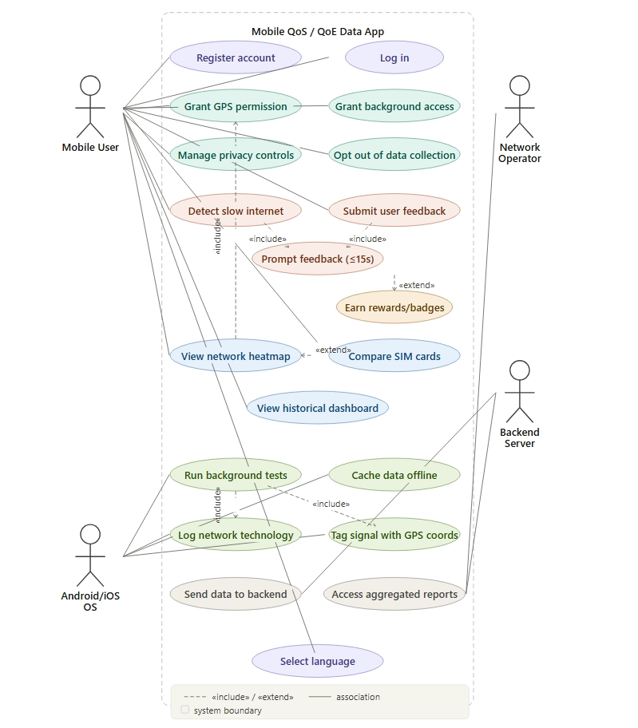5. Sequence Diagram

5.1 Overview
Sequence diagrams describe the chronological order of interactions between objects and components for a particular scenario or use case. They are particularly useful for clarifying the communication protocol between the mobile application, the device OS, and the backend server. Two key scenarios are described below: the passive metric collection cycle and the active feedback collection cycle.
5.2 Scenario A: Passive Metric Collection and Transmission
This scenario describes the periodic background collection of network and location metrics by the mobile application.

- Every 15 minutes, the Background Service initiates the metric collection process.
- The Background Service requests current network details from the Network/Telephone Manager using getNetworkDetails().
- The Network/Telephone Manager returns the current network type, RSRP, and signal strength values.
- The Background Service then requests the device location from the GPS Manager using getLocation().
- The GPS Manager returns the current latitude, longitude, and timestamp.
- The Background Service constructs a metric record containing the collected network and location data.
- The metric record is then saved through the Lifeline component using SaveMetricRecord().
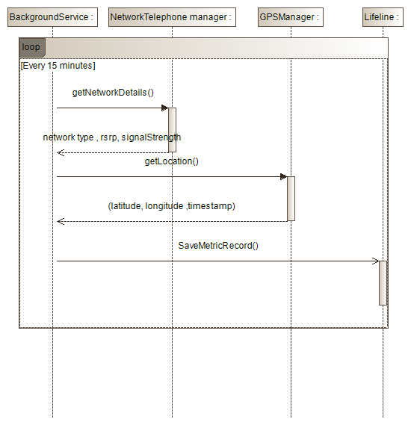
5.3 Scenario B: Active Feedback Collection
This scenario describes the process through which a feedback notification is presented to the subscriber and the submitted feedback is recorded locally.

- The Background Timer triggers the Notification Manager using triggerNotification().
- The Notification Manager sends a displayPrompt() request to the Subscriber to display the feedback notification.
- The Subscriber opens the feedback interface through openFeedbackForm() in the Feedback UI.
- The Subscriber submits the feedback using submitFeedback().
- The Feedback UI processes the submitted feedback and displays a success message to the subscriber.
- The feedback data (qoeData) is then stored in the LocalSQLiteDb using saveFeedback(qoeData).
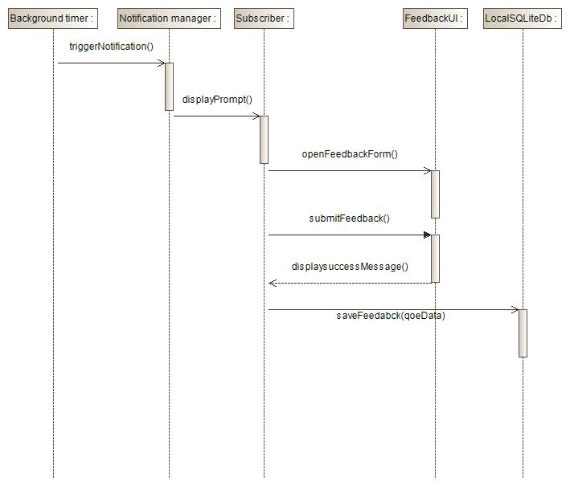
5.4 Data synchronization
This scenario describes the synchronization process in which locally stored records are transmitted to the remote server when network connectivity becomes available.
- The ConnectivityReceiver detects network availability and triggers the sync scheduler using onNetworkAvailable().
- If the connection is stable, the sync scheduler requests unsynchronized records from the LocalSQLiteDB using fetchUnsyncedata().
- The LocalSQLiteDB returns the pending payload records.
- The sync scheduler sends the collected payload to the RemoteAPI using uploadMetrics(payload).
- The RemoteAPI responds with an HTTP 200 OK confirmation after successful upload.
- Upon successful transmission, the sync scheduler updates the synchronization status by invoking markAsSynched().

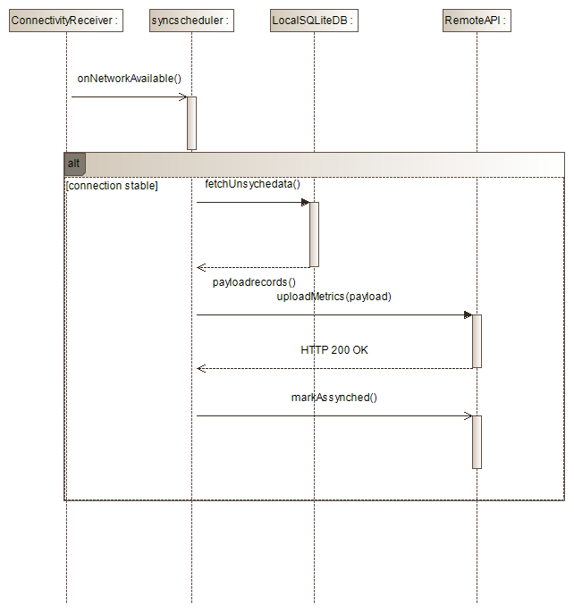

6. Class Diagram

6.1 Overview
The Class Diagram specifies the object-oriented structure of the mobile application. It defines the classes, their attributes and methods, and the relationships between them including association, aggregation, composition, and dependency. The diagram follows the UML 2.x standard and reflects the structure of the Android application layer of the system.

6.2 Core Classes
6.2.1 UserSession Represents an active session for a mobile user of the UX Data Collector app. Attributes include sessionId, anonUserId, optBackground, optLocation, optBatterySaver, and createdAt. Methods include updatePreferences() and getConsentStatus().
6.2.2 NetworkFeedback The central data entity that consolidates both passive network metrics and active user feedback for a single collection event. Attributes include feedbackId, sessionId, timestamp, rating, emoji, textComment, problemType, isAutomatic, and triggerType. Methods include saveToLocal(), queueForSync(), and anonymize().
6.2.3 NetworkMetric Encapsulates all passively collected objective network parameters gathered during a feedback event. Attributes include metricId, feedbackId, signalStrength, networkType, downloadSpeed, uploadSpeed, latency, and operator. Methods include calculateQualityScore() and validateMetrics().
6.2.4 LocationData Stores the geographic coordinates associated with a feedback entry, supporting spatial analysis. Attributes include locationId, feedbackId, latitude, longitude, accuracy, region, and isExact. Methods include anonymizeLocation() and validateCoordinates().
6.2.5 DataCollectionService The background service responsible for orchestrating passive data collection on the user's device. Attributes include isRunning, intervalMinutes, lastCollection, and batteryThreshold. Methods include startCollection(), stopCollection(), onSpeedDetected(), and onCallStateChanged().
6.2.6 RatingTriggerEngine Determines when to prompt the user for a rating based on network events and timing rules. Attributes include lastTrigger, cooldownMinutes, slowSpeedThreshold, and callDropDetection. Methods include checkSpeedAndTrigger(), onCallEnd(), and getRandomTrigger().
6.2.7 SyncManager Manages the upload of pending feedback records to the backend server. Attributes include pendingCount, lastSync, and isWiFiOnly. Methods include enqueue(feedback: NetworkFeedback), syncNow(), and onNetworkChange().
6.2.8 FeedbackActivity Handles the user-facing interface for submitting feedback, including rating selection and problem reporting. Attributes include currentRating, selectedEmoji, and problemsList. Methods include onSubmitClick(), onSkipClick(), and showConfirmation().
6.2.9 AggregatedTile Represents a geographic grid tile containing aggregated network quality statistics for heatmap rendering. Attributes include tileId, gridX, gridY, region, avgRating, avgSignal, reportCount, operatorBreakdown, and lastUpdated. Methods include calculateAverage() and generateTileData().
6.2.10 HeatMapRenderer Responsible for rendering the network quality heatmap visualisation within the app. Attributes include currentRegion, zoomLevel, and showOperator. Methods include loadTiles(), renderColorMap(), and filterByOperator().

6.3 Relationships
- DataCollectionService triggers RatingTriggerEngine (dependency), initiating the evaluation of whether a user prompt should be shown based on detected network events.
- RatingTriggerEngine creates NetworkFeedback (dependency), instantiating a new feedback record when trigger conditions are met.
- UserSession creates NetworkFeedback (association), linking each feedback entry to the current anonymous user session.
- NetworkFeedback contains NetworkMetric and contains LocationData (composition), meaning each feedback record is composed of exactly one metric snapshot and one location entry.
- NetworkMetric and LocationData are aggregated into AggregatedTile (aggregation), combining individual records into spatial grid tiles for analysis.
- SyncManager syncs NetworkFeedback (dependency), reading pending records and uploading them to the backend.
- FeedbackActivity creates/submits NetworkFeedback (dependency), generating feedback records from user interaction.
- HeatMapRenderer uses AggregatedTile (dependency), reading tile data to render the network quality heatmap.

6.4 Diagram
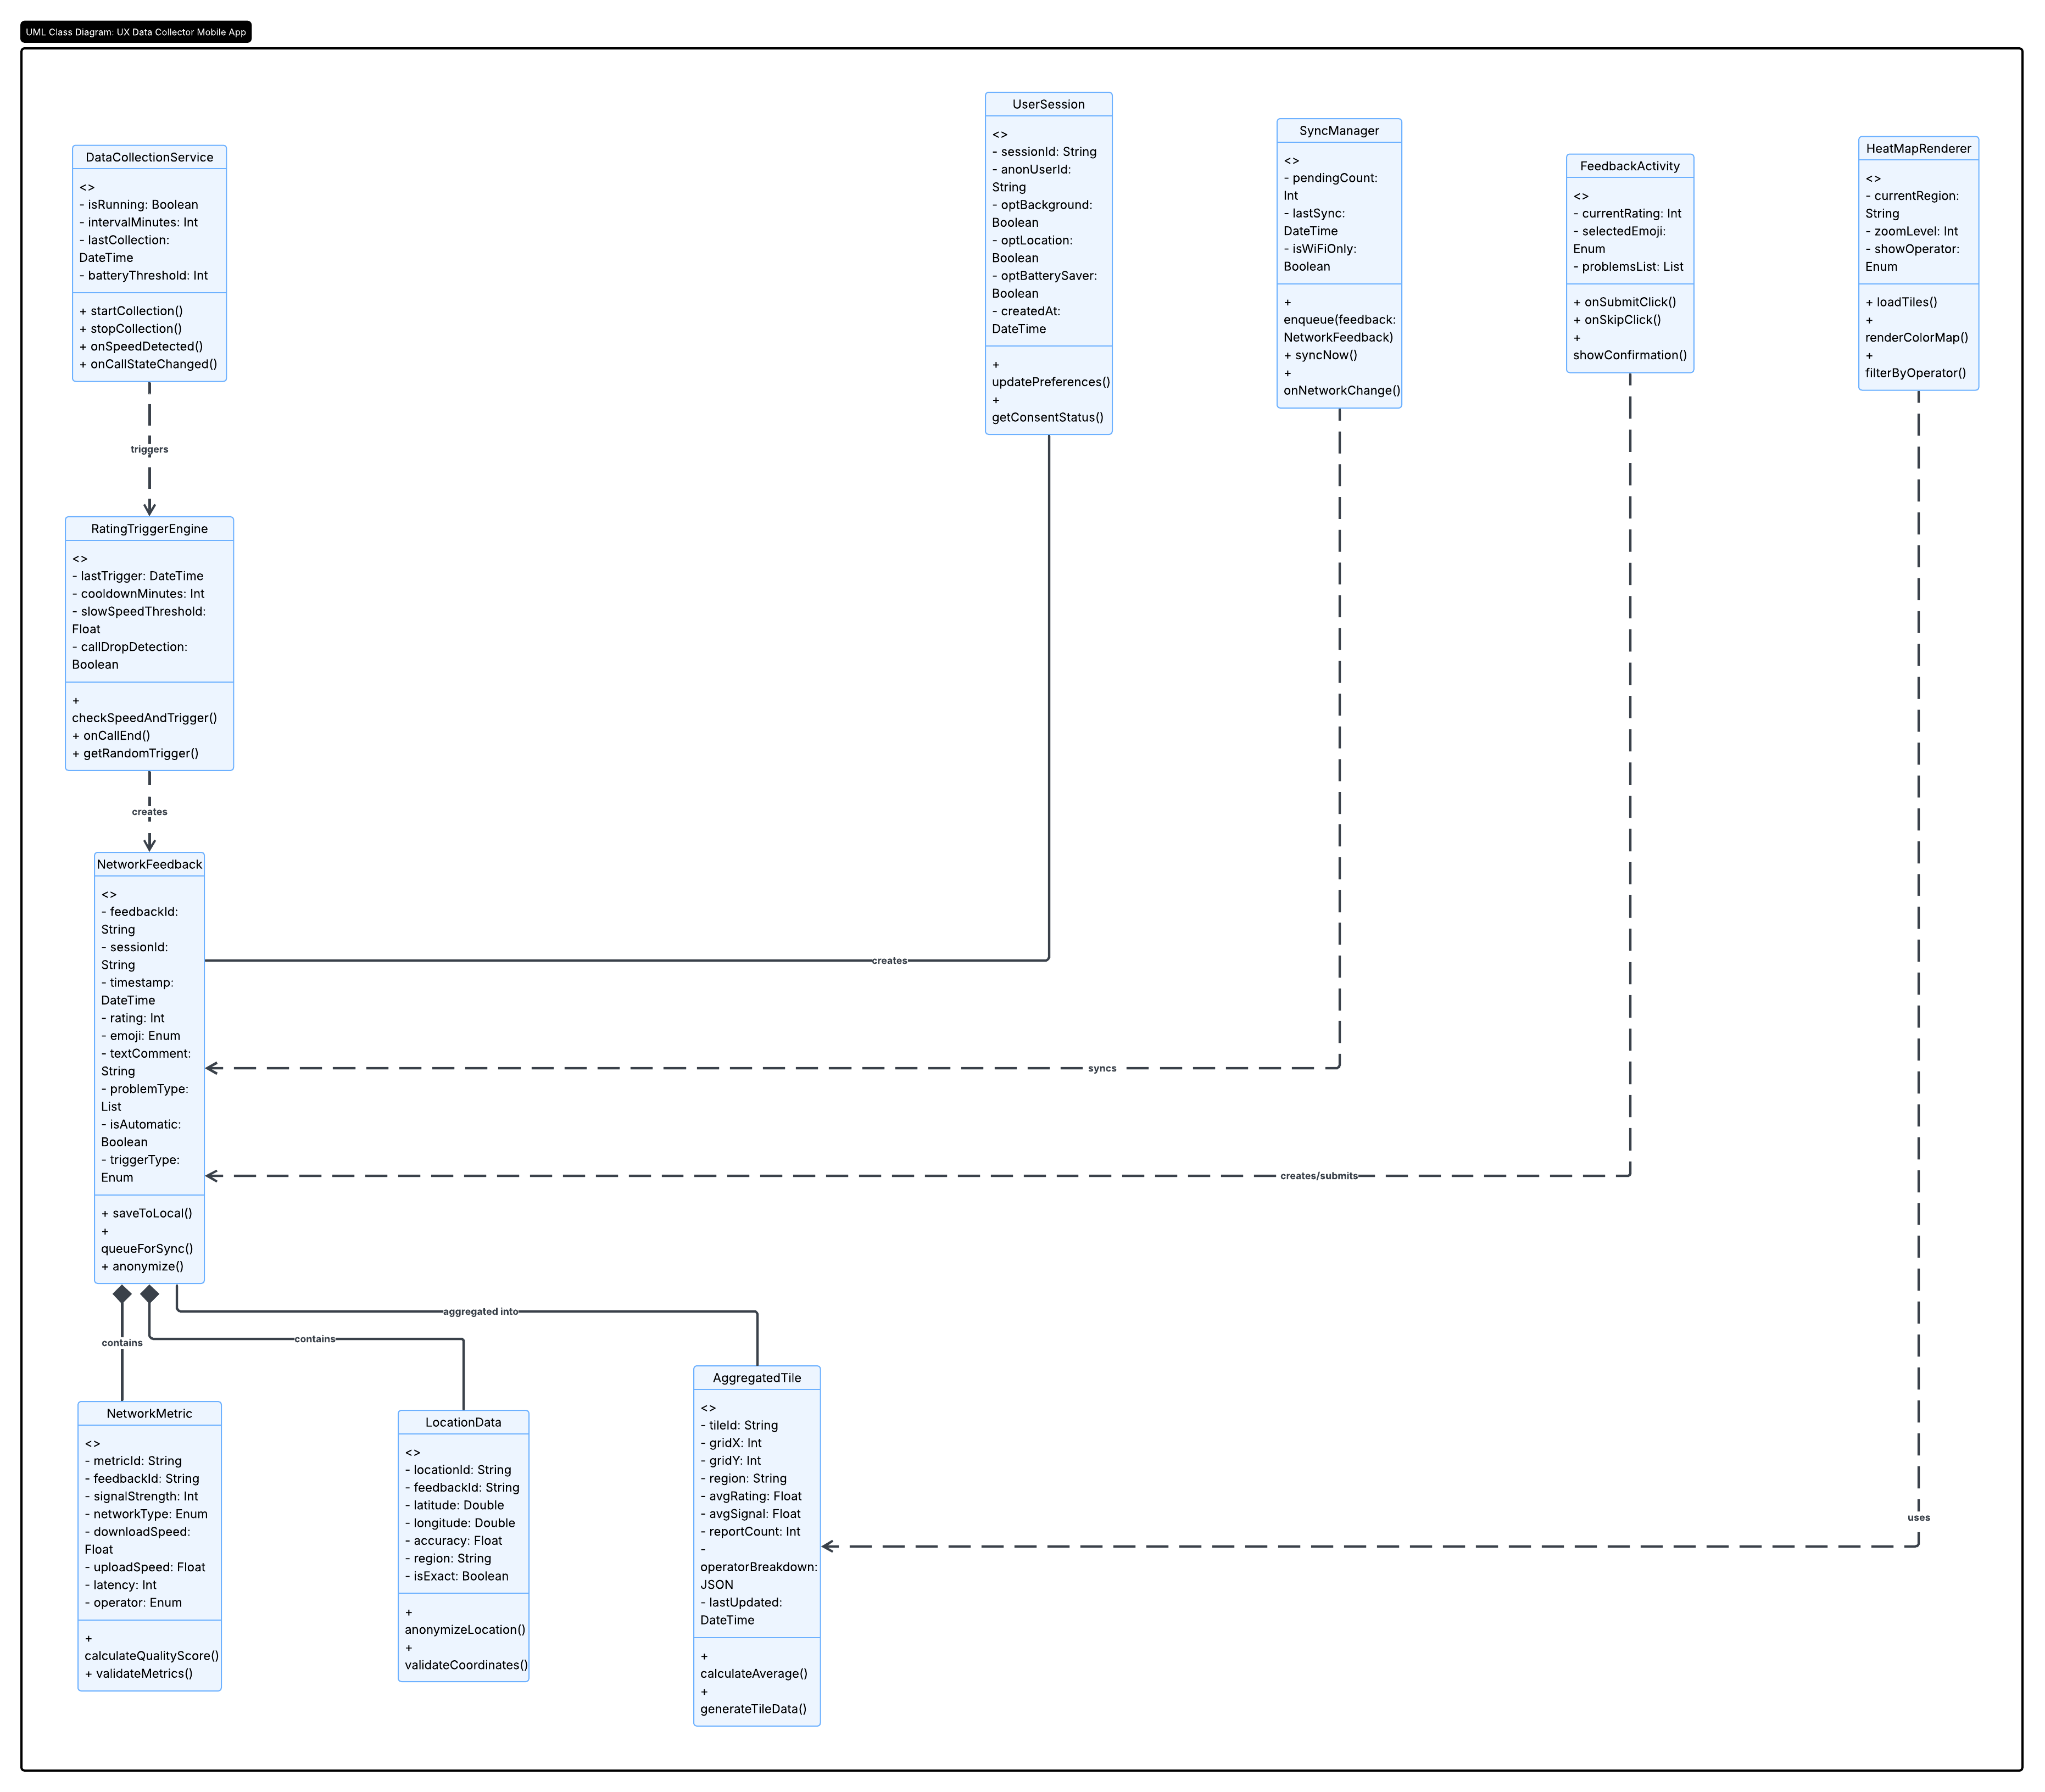

7. Deployment Diagram

7.1 Overview
The Deployment Diagram describes the physical and logical infrastructure on which the system components are deployed. It maps software artefacts to hardware nodes and communication paths, providing a complete picture of the operational environment. The diagram follows the UML 2.x deployment diagram notation.

7.2 Nodes

7.2.1 Subscriber Device Node
This node represents the Android smartphone owned by the mobile subscriber. It hosts the following artefacts:
- QoE Mobile Application (APK): The compiled Android application package containing all application logic.
- SQLite Local Database: The on-device relational data store for temporary record buffering.
- Android Runtime Environment: The execution environment providing OS services, network APIs, and location services.
7.2.2 Mobile Network Infrastructure Node
This node represents the telecommunications network through which the device communicates with external servers. It includes the Radio Access Network (RAN), core network elements, and the Internet gateway. Communication between the device and backend server traverses this infrastructure.
7.2.3 Backend Application Server Node
This node represents the cloud-hosted or data-centre-hosted application server responsible for receiving, processing, and serving QoE data. It hosts the following artefacts:
- REST API Service: A RESTful web service that exposes endpoints for data ingestion from mobile devices and data retrieval by the operator portal.
- Data Processing Module: Performs preprocessing, validation, and aggregation of incoming QoE records.
- Authentication Service: Manages API key validation and subscriber token authentication.
7.2.4 Database Server Node
This node hosts the centralised relational database management system (RDBMS), such as PostgreSQL, that persistently stores all QoE records received from subscriber devices. It is connected to the Backend Application Server via a private internal network link.
7.2.5 Operator Portal Node
This node represents the workstation or web browser used by the Mobile Network Operator to access the analytics dashboard. It communicates with the Backend Application Server over HTTPS and is typically located within the operator's corporate network, potentially behind a VPN or firewall.
7.3 Communication Paths
- Subscriber Device to Backend Server: HTTPS over the mobile data network (4G/5G or Wi-Fi). All payloads are encrypted using TLS 1.2 or higher.
- Backend Application Server to Database Server: Private TCP connection within the hosting environment, not exposed to the public internet.
- Operator Portal to Backend Server: HTTPS, typically with additional access controls such as VPN or IP whitelisting enforced at the network boundary.
8. Conclusion

Six UML diagrams document the QoE Data Collection Mobile Application from system boundary to deployment infrastructure. Each diagram addresses a distinct design perspective: context (external actors), dataflow (internal processes and data stores), use cases (functional requirements), sequence (interaction timing), class (object-oriented structure), and deployment (hardware and communication protocols). Together they form a complete design foundation for implementation, testing, and future maintenance of the system.

